Basic SPI Interview Questions
- What is SPI
Basic Features
- Full-Duplex Communication: Data can be transmitted and received simultaneously.
- Master-Slave Architecture: One master can control one or multiple slave devices.
- Four Signal Lines:
  - MOSI (Master Out Slave In)
  - MISO (Master In Slave Out)
  - SCLK (Serial Clock)
  - SS/CS (Slave Select/Chip Select)
- Synchronous Protocol: Uses a shared clock for data synchronization between devices.
🔹 Electrical & Timing Features
- High Speed: Can operate at higher clock speeds than I2C (up to tens of MHz).
- Clock Polarity and Phase Control (CPOL, CPHA): Supports 4 SPI modes to match slave timing.
- No Start/Stop Conditions: Unlike I2C, SPI does not need special conditions to begin/end communication.
🔹 Configurability
- Multi-Slave Support: Multiple slaves can be used with separate CS lines or daisy-chaining.
- Simple Hardware Interface: No need for addressing; simpler logic than I2C.
- Flexible Data Frame Size: Typically 8 bits, but configurable to 16 or more depending on the hardware.
🔹 Limitations
- No Acknowledgment Mechanism: Lacks built-in ACK/NACK like I2C.
- Short-Distance Communication: Best suited for board-level communication.
- Requires More Pins: More I/O lines needed compared to I2C or UART.

- Why is SPI called a full-duplex communication protocol?
SPI (Serial Peripheral Interface) is called a full-duplex communication protocol because it allows simultaneous data transmission and reception between the master and slave devices.
In SPI, there are two separate data lines:
- MOSI (Master Out Slave In) – Used for sending data from master to slave.
- MISO (Master In Slave Out) – Used for sending data from slave to master.
Both lines can operate at the same time, which means while the master sends data to the slave over MOSI, the slave can simultaneously send data back to the master over MISO. This concurrent bidirectional data flow is what makes SPI a full-duplex protocol.

- How many wires are used in SPI? Name them.
SPI (Serial Peripheral Interface) typically uses 4 wires for communication:
- MOSI (Master Out Slave In) – Carries data from the master to the slave.
- MISO (Master In Slave Out) – Carries data from the slave to the master.
- SCLK (Serial Clock) – Clock signal generated by the master to synchronize data transfer.
- SS or CS (Slave Select or Chip Select) – Used by the master to select the specific slave device (active low signal).
In systems with multiple slaves, each slave usually has its own CS line.

- What is the role of each SPI signal (MOSI, MISO, SCLK, SS)?
MOSI (Master Out Slave In):
- Transmits data from the master to the slave.
- Used when the master sends commands or data to the slave device.
MISO (Master In Slave Out):
- Transmits data from the slave to the master.
- Used when the slave responds with data to the master.
SCLK (Serial Clock):
- Clock signal generated by the master.
- Synchronizes data transmission between master and slave.
- All data bits are shifted in/out on the edges of this clock.
SS or CS (Slave Select or Chip Select):
- Active-low signal used by the master to select a specific slave.
- When SS = 0 (LOW), the selected slave is enabled for communication.
- When SS = 1 (HIGH), the slave ignores the SPI bus.

- Explain the master-slave concept in SPI.
In SPI communication, the master-slave concept defines the roles of devices involved in data transfer:
- Master:
  - Controls the entire communication.
  - Generates the clock signal (SCLK) to synchronize data transfer.
  - Initiates data transmission by selecting a slave using the Slave Select (SS) line.
  - Sends data to the slave via MOSI and receives data from the slave via MISO simultaneously.
  - Only one master is typically present on the SPI bus.
- Slave:
  - Responds to the master's commands.
  - Listens to the clock signal provided by the master to synchronize data reception and transmission.
  - Transmits data back to the master via MISO and receives data from the master via MOSI.
  - Each slave device has a dedicated SS line from the master to enable or disable communication. When the slave’s SS line is LOW, the slave is selected and communicates; when HIGH, the slave ignores the bus.

- Can SPI support multiple slave devices? If yes, how?
Yes, SPI can support multiple slave devices on the same bus.
How it works:
- The master has separate Slave Select (SS) lines for each slave device.
- Each slave device’s SS pin is connected to a dedicated master output line.
- To communicate with a particular slave, the master pulls that slave’s SS line LOW (active low) while keeping the other slaves’ SS lines HIGH.
- Only the selected slave responds to the SPI clock and data lines (MOSI and MISO).
- This method allows multiple slaves to share the MOSI, MISO, and SCLK lines, but only one slave is active at a time.
Example:
If there are 3 slaves, the master will have 3 SS lines:
- SS1 → Slave 1
- SS2 → Slave 2
- SS3 → Slave 3
To talk to Slave 2, the master sets SS2 LOW and SS1, SS3 HIGH.

- What is the difference between SPI and I2C?
- Is SPI synchronous or asynchronous? Explain.
SPI is a synchronous communication protocol.
Explanation:
- In synchronous communication, both the sender and receiver share a common clock signal to coordinate data transfer.
- In SPI, the master generates the clock signal (SCLK) which synchronizes the data transmission and reception between master and slave devices.
- Data bits are shifted in and out on the edges (rising or falling) of this clock.
- Because data transfer happens in sync with the clock pulses, SPI is considered synchronous.

- What is the data rate of SPI communication?
The data rate of SPI communication depends on the clock frequency generated by the master. Typically, SPI clock speeds range from a few kilohertz up to several megahertz, commonly around 1 to 50 MHz, depending on the hardware capabilities. Since SPI transfers one bit per clock cycle and supports full-duplex communication, the effective data rate is basically equal to the clock speed.
- What is the typical voltage level used in SPI communication?
🔹 Intermediate SPI Interview Questions
- Explain SPI clock polarity (CPOL) and clock phase (CPHA).
SPI communication uses two important clock settings: Clock Polarity (CPOL) and Clock Phase (CPHA). These settings define how data is sampled and shifted relative to the clock signal.
- Clock Polarity (CPOL):
  - Determines the idle state of the clock line (SCLK).
  - If CPOL = 0, the clock is low (0V) when idle.
  - If CPOL = 1, the clock is high (logic 1) when idle.
- Clock Phase (CPHA):
  - Determines when data is sampled and shifted relative to the clock edges.
  - If CPHA = 0, data is sampled on the first clock edge (rising or falling, depending on CPOL) and shifted on the opposite edge.
  - If CPHA = 1, data is sampled on the second clock edge and shifted on the first.

- What are the different SPI modes? How are they defined?
• Toggling edge:
The clock edge where the data line changes (data is output or shifted out).
• Sampling edge:
The clock edge where the data is read or sampled by the receiver.
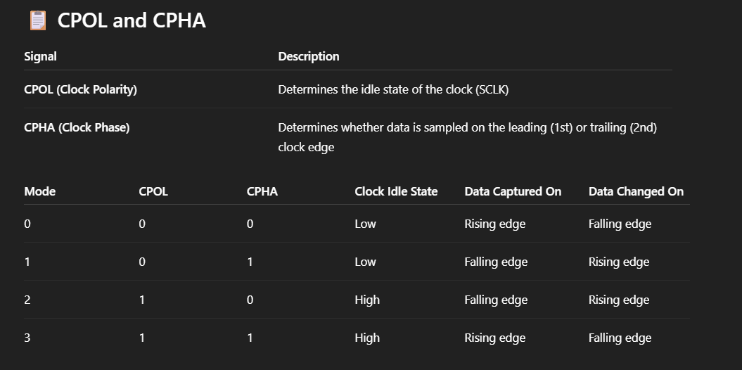

- How is data framed and transmitted in SPI?
1. Frame Structure in SPI
An SPI frame typically includes:
Field | Description
SS/CS | Slave Select line – pulled LOW to start frame
Clock | SCLK signal – generated by Master
Data | MOSI (Master Out Slave In) and MISO (Slave Out Master In) carry the data
Frame size | Usually 8 bits, but can be 4 to 16 bits or more depending on configuration

🔸 2. Transmission Process
Step-by-step Explanation:
- Master pulls SS/CS LOW
→ This selects the specific slave and initiates communication.
- Master generates clock (SCLK)
→ Clock speed is set by the master. Slave is driven by this clock.
- Data is shifted bit by bit
  - Master sends data via MOSI
  - Slave sends data via MISO
  - Data is shifted one bit per clock cycle
- Framing happens via clock edges:
  - Depending on SPI Mode (0–3), data is sampled on rising or falling edge of SCLK.
- After the final bit is transmitted, the master can:
  - Keep SS/CS low (for continuous transmission)
  - Or pull it HIGH to end the frame
- What happens if two slaves are selected at the same time in SPI?
What is the maximum number of slaves that can be connected in SPI?
- Can SPI be used for long-distance communication? Why or why not
Lack of Differential Signaling:
- SPI uses single-ended signaling (like standard logic HIGH/LOW).
- It is more susceptible to noise and signal distortion over long cables.
- Unlike protocols like RS-485 or CAN, SPI has no noise immunity features for long-distance environments.
2. No Built-in Error Detection:
- SPI does not include error-checking mechanisms (like parity bits or CRC).
- In long cables, signal integrity degrades, and there’s no way to detect corrupted data.
3. Signal Degradation (Skew and Delay):
- SPI uses multiple lines (MOSI, MISO, SCK, CS) — all must be synchronized.
- Over long distances, skew (timing differences between lines) causes data mismatches.
- Clock signals also degrade, affecting timing accuracy.

Standard SPI (with individual CS lines):
- Each slave needs a separate CS/SS (Chip Select) line from the master.
- If the master has N GPIO pins available for CS, you can connect up to N slaves.
Example:
  - If the microcontroller has 4 available GPIOs, you can connect 4 SPI slaves.
2. Limitations:
- GPIO availability: Limited CS pins may restrict the number of slaves.
- Signal integrity: Long wires or many devices on the same SPI lines (SCK, MOSI, MISO) can cause signal degradation.
- Fan-out: Each SPI line can only drive a limited number of inputs before voltage and timing issues arise.

🔁 Alternative: Daisy-Chained SPI (used in some chips like shift registers or certain DACs):
- Some SPI-compatible devices support daisy-chaining, where data flows from one slave to the next.
- In this mode, all devices share the same CS, and the number of slaves can be higher.
- But this depends on the slave hardware design.

Feature | UART | I2C | SPI | CAN
Communication Type | Asynchronous | Synchronous | Synchronous | Synchronous, multi-master
Devices Supported | 1-to-1 | Multi-slave (127 max) | Multi-slave via CS | Multi-node (up to 110 nodes)
Pins Required | 2 (TX/RX) | 2 (SDA/SCL) | 3–4 (MISO, MOSI, SCK, CS per slave) | 2 (CAN_H, CAN_L)
Speed | 110 bps – 3 Mbps | 100 kbps – 3.4 Mbps | 1 Mbps – 50+ Mbps | 10 kbps – 1 Mbps (Classic), up to 5 Mbps (FD)
Data Transfer | Half/full duplex | Half-duplex | Full-duplex | Multi-master, priority-based
Addressing | None | Slave address | CS line per slave | Message ID arbitration
Why Separate | Simple point-to-point | Shared bus, low pin count | Fast, full-duplex | Robust multi-node network, error detection

